

Autonomous college affiliated to VTU, Accredited by NBA and NAAC with “A” grade

**SMART BUS LANE**

**A MINI PROJECT**

**REPORT**

**SUBMITTED BY:**

CHITRA.S-1NH18EE010

E.KAVIPRIYA-1NH18EE013

GREESHMA CHENNAREDDY-1NH18EE017

***In partial fulfilment for the award of the degree of***

**BACHELOR OF ENGINEERING**

**IN**

**ELECTRICAL AND ELECTRONICS ENGINEERING**



Autonomous college affiliated to VTU, Accredited by NBA and NAAC with “A” grade

**BONAFIDE CERTIFICATE**

This is to bonafide that the mini project report entitled “SMART BUS LANE” submitted by CHITRA.S(1NH18EE010),E.KAVIPRIYA(1NH18EE013) and GREESHMA CHENNAREDDY(1NH18EE017) Department of Electrical Engineering, New Horizon College of Engineering, Bangalore in partial fulfilment for the award of the degree of bachelor of engineering, is a record of bonafide work carried out by him/her under my supervision, as per the NHCE code of academic and research ethics.

The contents of this report have not been submitted and will not be submitted either in part or in full, for the award of any other degree or diploma in this institute or any other institute or university. The project report fulfils the requirements and regulations of the institution and in my opinion meets the necessary standards for submission.

Mr. Joshua Daniel Raj Dr. S. Ramkumar

Project Guide HoD



Autonomous college affiliated to VTU, Accredited by NBA and NAAC with “A” grade

**ACKNOWLEDGEMENT**

With immense pleasure and deep sense of gratitude, We wish to express our sincere thanks to our supervisor Mr. Joshua Daniel Raj, Senior Assistant professor, Department of Electrical Engineering, New Horizon College of Engineering, without his motivation and continuous encouragement, this mini project would not have been successfully completed.

We are grateful to the chairman of New Horizon Educational institution, Dr. Mohan Manghnani for motivating us to carry out research in NHCE and for providing us with infrastructural facilities and many other resources needed for our project work.

We express our sincere thanks to Dr. S Ramkumar, HOD, Department of Electrical Engineering, New Horizon College of Engineering for his kind words of support and encouragement.

We wish to extend our profound sense of gratitude to our parents for all the sacrifices they made during our project and providing us with moral support and encouragement whenever required.

Date:

Place:Bangalore

Chitra. S

E. Kavipriya

Greeshma Chennareddy

**TABLE OF CONTENTS**

1. **ABSTRACT**
2. **INTRODUCTION**
3. **CIRCUIT DIAGRAM**
4. **HARDWARE REQUIREMENTS**
5. **CIRCUIT DIAGRAM AND WORKING**
6. **RESULTS**
7. **CONCLUSION**
8. **BIBLIOGRAPHY**
9. **APPENDICES**

**ABSTRACT**

Nowadays, Trustworthiness in public transport is of great importance. People who use public transport waste a lot of time waiting for bus at the bus stop. In the operation of the public transport on road which mainly comprises of the BMTC bus system, the movement of buses is affected by traffic.

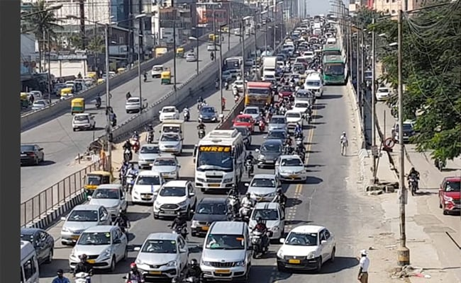

Fig.1.1 Traffic

The recent implementation of bus lanes by the Government of Karnataka was named the BMTC’s bus priority lane project in ORR (Outer Ring Road). The initial goal is to increase the average speed of buses on this route from about 10kmph to 18-20kmph. Designation of bus lane means implementing the priority of urban bus system by using portion of the road resources, thus impacting the traffic. The aim of this work is to reduce travel time of buses in reaching the destination and also reduce traffic in Bangalore city.

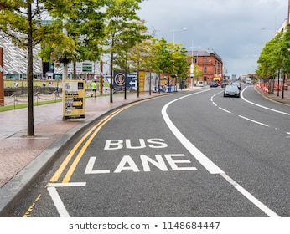

Fig.1.2 Bus Lane

With the aim of proposing the scope and extent of the impact, our project aims at implementing the already existing idea of bus lane effectively by using PIR sensors to detect the movement of vehicles and send a signal to the arduino and the output would in turn allow the movement of only buses on the bus lane.

**INTRODUCTION**

In recent years, the number of vehicles owned increased sharply in many cities, which has a negative impact on public transportation which includes violation of traffic rules as one of the main reason. As a result, public transportation vehicles cannot run smoothly and the reliability of transit can hardly be guaranteed. For the lack of road resources and high costs of transport infrastructure, making use of the existing road sections to designate bus lanes has become one of the effective ways to implement public transportation priority. The travel condition of buses can be improved and the reliability of the public transport can also be guaranteed through the setup of bus lanes.

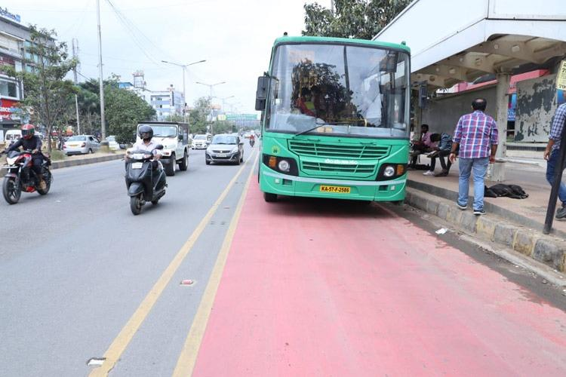

Fig.2.1

A dedicated bus lane was introduced in Bangalore a few months ago that has helped cut the time taken for bus journey. The BMTC bus which is a public transport and is being used by a large amount of public has been given a part of the road for its movement. The BMTC, the BBMP and the traffic police have come together to create a unique bus priority lane for almost 22km.

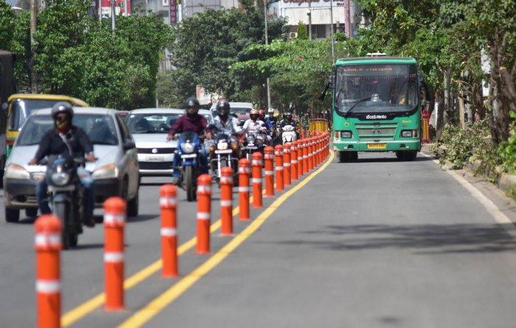

Fig.2.2

The city’s first bus priority lane on Outer Ring Road appears to have all but vanished. With poor enforcement by traffic police and absence of a physical barricade along the busy stretch, buses are getting an exception on the lane as a matter of exception and not as a rule. The ambitious project was rolled out by agencies like BBMP, BMTC, traffic police and the directorate of urban land on November 15. But in just about two months, the yellow marking demarcating the lane has faded away on several sections.

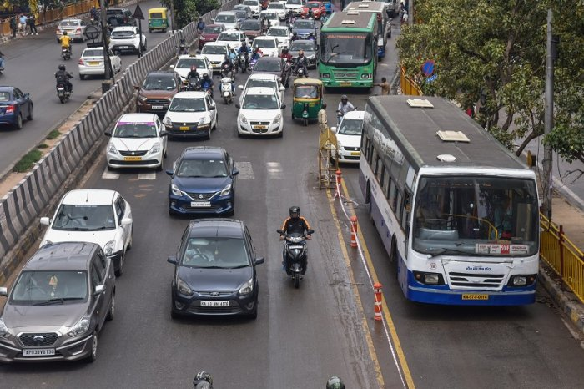

Fig.2.3

Therefore the main objective of our project is to bring back the idea of a smart bus lane by using technology and with less human intervention.

**BLOCK DIAGRAM**

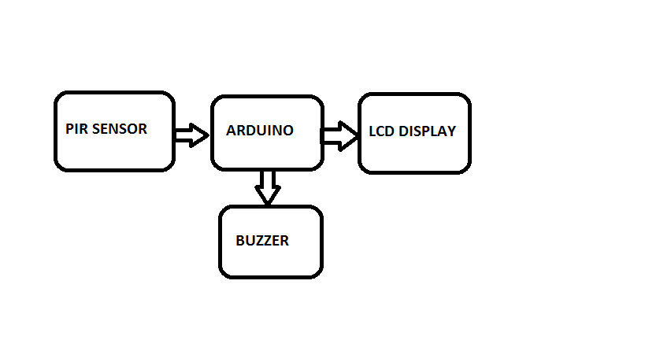

Fig.3. Block Diagram

Two PIR sensors are installed one at the level of the ground and other at the height of a bus. When no vehicle passes through the sensors give zero output the LCD will display a message FOLLOW TRAFFIC RULES. When a bus enters the green LED glows and the LCD will display a message WELCOME BMTC. When any other vehicle like a motorbike or car enters the bus lane the red LED glows and the buzzer will turn on with a message CHANGE YOUR LANE on the LCD.

**CIRCUIT DIAGRAM**

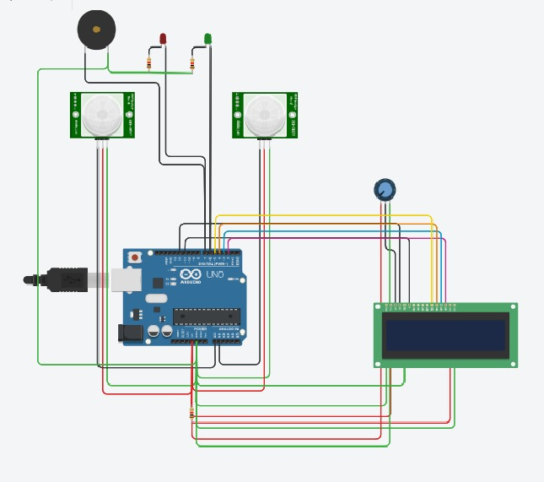

Fig.4. Circuit diagram of Smart bus lane

**CIRCUIT WORKING**

The following is the program code for arduino programming on which the circuit works.

unsigned long int buzzer=8;

unsigned long int LED1=7;

unsigned long int LED2=6;

#include<LiquidCrystal.h>

LiquidCrystal LCD(10,9,5,4,3,2);

void setup()

{

pinMode(LED1, OUTPUT);

pinMode(LED2, OUTPUT);

pinMode(buzzer, OUTPUT);

pinMode(A0, INPUT);

pinMode(A1, INPUT);

LCD.begin(16,2);

}

void loop()

{

if(digitalRead(A0)==HIGH && digitalRead(A1)==HIGH)

{

LCD.setCursor(0,0);

LCD.print("WELCOME BMTC BUS");

digitalWrite(LED2, HIGH);

digitalWrite(LED1, LOW);

digitalWrite(buzzer, LOW);

}

else if(digitalRead(A0)==HIGH && digitalRead(A1)==LOW)

{

LCD.setCursor(0,0);

LCD.print("CHANGE YOUR LANE");

digitalWrite(LED1, HIGH);

digitalWrite(buzzer, HIGH);

digitalWrite(LED2, LOW);

}

else

{

LCD.setCursor(0,0);

LCD.print("FOLLOW RULES ");

digitalWrite(LED2, LOW);

digitalWrite(LED1, LOW);

digitalWrite(buzzer, LOW);

}

}

Two PIR sensors are placed one at the level of the road and the other at the height of the bus. When a bus enters the bus lane the sensor placed above and the sensor placed at the level of the road read HIGH, the GREEN LED glows and the LCD displays a message WELCOME BMTC BUS. When any other vehicle other than a bus such as a motorbike, car enters the lane the sensor placed at the level of the road reads HIGH, the buzzer buzzes and the RED LED glows with a message CHANGE YOUR LANE displayed on the LCD. When no vehicle enters the lane both the sensors read LOW and the LCD displays a message FOLLOW RULES.

**LIST OF COMPONENTS**

|  |  |  |
| --- | --- | --- |
| SL.NO | COMPONENTS | VALUE |
| 1. | PIR SENSOR |  |
| 2. | POTENTIOMETER | 100K |
| 3. | ARDUINO UNO |  |
| 4. | LCD | 16X2 |
| 5. | BUZZER |  |
| 6. | RESISTORS(2) | 1K |
| 7. | LED (LIGHT EMITTING DIODE)(2) | RED,GREEN |

**LIST OF FIGURES**

* Fig.1.1.Traffic
* Fig.1.2.Bus lane
* Fig.2.1.Introduction
* Fig.2.2.Introduction
* Fig.2.3.Introduction
* Fig.3.Block Diagram
* Fig.4.Circuit Diagram of Smart Bus Lane
* Fig.5. Resistors
* Fig.6. Colour code of resistors
* Fig.7. PIR sensor
* Fig.8.Arduino
* Fig.9. Potentiometer
* Fig.10.1.Light emitting diodes (LEDs)
* Fig.10.2.Parts of LED
* Fig.11.LCD
* Fig.12.Buzzer

**HARDWARE REQUIREMENTS**

The circuit diagram of Smart Bus lane consists of two PIR sensors where one is placed a little above ground level and the other at the height of a bus. The PIR sends the signal to the arduino and accordingly the message is displayed on the LCD for the entry of respective vehicles. The GREEN LED glows when a bus enters the lane and the RED LED glows when any other vehicle other than the bus enters.

**SPECIFICATION OF COMPONENTS:**

**RESISTOR**

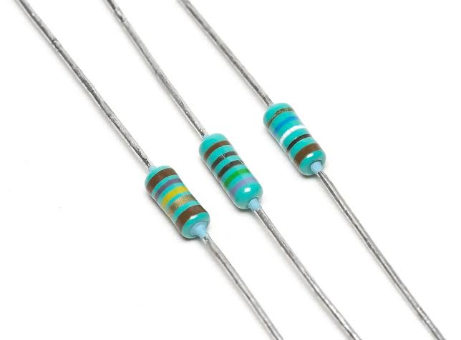

Fig.5. Resistors

A resistor offers a resistance to the flow of current and act as voltage droppers or voltage dividers. They are “Passive Devices”, that is they contain no source of power or amplification but only attenuates or reduces the voltage signal passing through them. For high current operations resistance of higher current ratings are used. Resistance is the opposition that a substance offers to the flow of electric current. It is represented by ‘R’. The standard unit of resistance is ohm. When an electric current of one ampere passes through a component across which a potential difference (voltage) of one volt exists, then the resistance of that component is one ohm.

In general, When the applied voltage is held constant, the current in a direct-current (DC) electrical circuit is inversely proportional to the resistance. If the resistance is doubled, the current is cut in half; If the resistance is halved, the current is doubled. This rule also holds true for most low-frequency alternating AC systems, such as household utility circuits. In some AC circuits, especially at high frequencies, the situation is more complex, because some components in these systems can store and release energy, as well as dissipating and converting it.

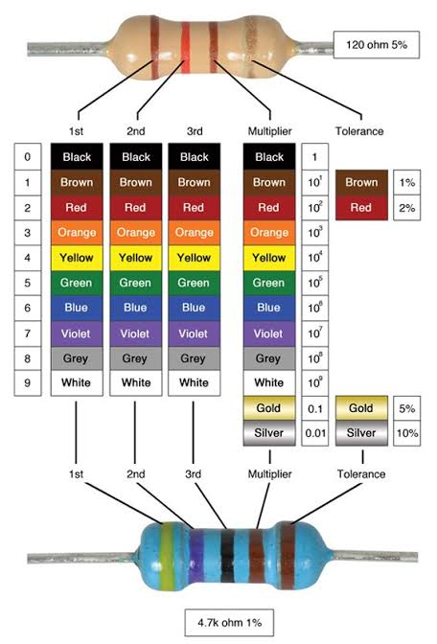

Fig. 6. Colour code of resistors

**PIR SENSOR**

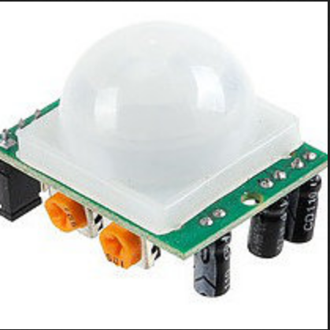

Fig. 7. PIR sensor

PIR stands for Pyroelectic Infrared Radial Sensor or Passive Infrared Sensor. PIR is an electronic sensor which detects the changes in the infrared light across certain distance and gives out an electrical signal at its output in response to a detected IR signal. It can detect any infrared emitting object such as human beings or animals if it is the range of the sensor, or moves away from the range, or moves within the range of the sensor.  
The PIR sensor module can be divided in to two parts an infrared sensitive crystal and the processing circuit. The dark portion of the metal where the IR sensitive crystal is housed, the sensitive crystal can detect the level of infrared in the surroundings. It actually houses two pyroelectic sensors for detecting moving objects. If one of the sensitive crystals detects change in infrared (increment or decrement) than the other sensitive crystal, the output gets triggered.

A dome shaped plastic structure is normally placed over this sensitive crystal which acts as lens to focus the infrared light on the sensors. The sensing operation of a pyroelectric infrared sensor is based on the property or characteristic which becomes responsible for altering the polarization of its material in response to temperature changes.

These sensors employ a dual or a pair of sensing elements for sensing the IR signals in two steps, which ensures a foolproof detection by cancelling the unwanted temperature variations within the existing EMI stage. This two-step sensing process improves the overall stability of the sensor and helps to detect IR signals only from human presence.

When a human being or a relevant IR source moves past a PIR sensor, the radiation cuts into the pair of sensing elements in an alternate manner, triggering the output to generate a pair of ON/OFF or high and low pulses.

**ARDUINO UNO**

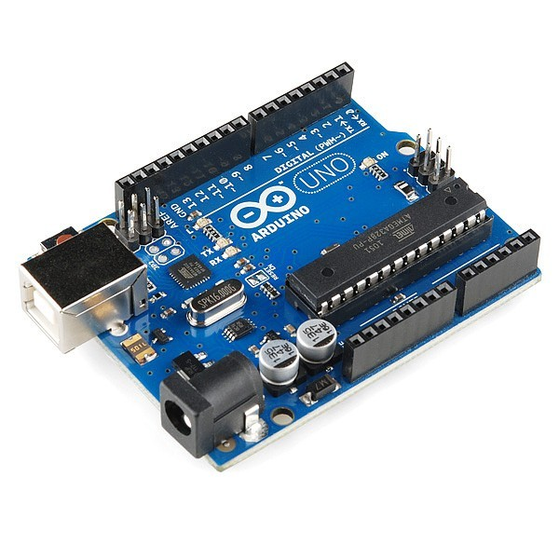

Fig.8. Arduino UNO Board

Arduino Uno is a microcontroller board based on the ATmeg328P(datasheet). It has 14 digital input/output pins(of which 6 can be used as PWM outputs), 6 analog inputs, a 16MHz quartz crystal, a USB connection, a power jack, an ICSP header and a reset button. The 14 digital input/output pins can be used as input or output pins by using pinMode(), digitalRead() and digitalWrite() functions in arduino programming. Each pin operate at 5V and can provide or receive a maximum of 40mA current, and has an internal pull-up resistor of 20-50 KOhms which are disconnected by default.  Out of these 14 pins, some pins have specific functions as listed below:

* **Serial Pins 0 (Rx) and 1 (Tx):** Rx and Tx pins are used to receive and transmit TTL serial data. They are connected with the corresponding ATmega328P USB to TTL serial chip.
* **External Interrupt Pins 2 and 3:** These pins can be configured to trigger an interrupt on a low value, a rising or falling edge, or a change in value.
* **PWM Pins 3, 5, 6, 9 and 11:** These pins provide an 8-bit PWM output by using analogWrite() function.
* **SPI Pins 10 (SS), 11 (MOSI), 12 (MISO) and 13 (SCK):** These pins are used for SPI communication.
* **In-built LED Pin 13:** This pin is connected with an built-in LED, when pin 13 is HIGH – LED is on and when pin 13 is LOW, its off.

Along with 14 Digital pins, there are 6 analog input pins, each of which provide 10 bits of resolution, i.e. 1024 different values. They measure from 0 to 5 volts but this limit can be increased by using AREF pin with analog Reference() function.

* Analog pin 4 (SDA) and pin 5 (SCA) also used for TWI communication using Wire library.

Arduino Uno has a couple of other pins as explained below:

* **AREF:** Used to provide reference voltage for analog inputs with analogReference() function.
* **Reset Pin:**Making this pin LOW, resets the microcontroller.

**POTENTIOMETER**

A potentiometer informally a pot is a three-terminal resistor with a sliding contact that forms an adjustable voltage divider. If only two terminals are used, one end and the wiper, it acts as a variable resistor or rheostat. A potentiometer measuring instrument is essentially a voltage divider used for measuring electric (voltage); the component is an implementation of the same principle, hence its name. Potentiometers are commonly used to control electrical devices such as volume controls on audio equipment. Potentiometers operated by a mechanism can be used as potential transducers, for example, in a joystick. Potentiometers are rarely used to directly control significant power (more than a watt), since the power dissipated in the potentiometer would be comparable to the power in the controlled load. As shown in the diagram a variable resistor consists of track which provides the resistance path. Two terminals of the device are connected to both the ends of the track. The motion of the wiper through the track helps in increasing and decreasing the resistance.

The track is usually made of a mixture of ceramic and metal or can be made of carbon as well. As a resistive material is needed, carbon film type variable resistors are mostly used. They find applications in radio receiver circuits, audio amplifier circuits and TV receivers. For applications of small resistances, the resistance track may just be coil of wire. The track can be in both the rotary as well as straight versions. In a rotary track some of them may include a switch. The switch will have an operating shaft which can be easily moved in the axial direction with one of its moving from the body of the variable resistor switch. The rotary track resistor has two applications. One is to charge the resistance. The switch mechanism is used for the electric contact and non-contact by on/off operation of the switch. There are switch mechanism variable resistors with annular cross-section which are used for the control of equipment. Even more components are added onto this type of a variable resistor so as to make them compatible foe complicated electronic circuits. A high voltage variable resistor such as a focus pack is an example. This device is capable of producing a variable focus voltage as well as a screen voltage. It is also connected to a variable resistance circuit and also a fixed resistance circuit (bleeder resistor) to bring a change in the applied voltage. For this both the fixed and the variable resistor are connected in series. A track made in a straight path is called a slider. As a position of a slider cannot be seen or confirmed according to the adjustment of resistance, a stopping mechanism is usually included to prevent the hazards caused due to over rotation.

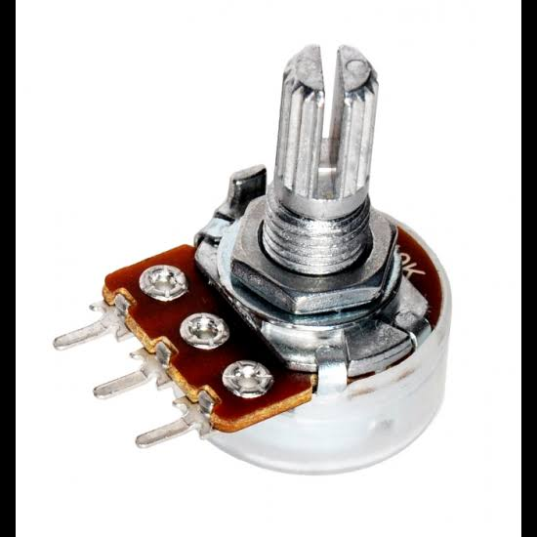

Fig.9. Potentiometer

**LED (Light Emitting Diode)**

The main specification of LED are its current rating = 20 mA, typical cut in voltage= 2 V, life time= 2 lakh hours, approx. voltage is around 4.5 V. There is different colour LED’s depending on the semi conducting material. LED has two leads – cathode and anode. They are identified by the length of the lead. Cathode lead is of lesser length. The maximum value of 470 ohm can be inserted for a small light.

LED is a semiconductor light source that emits light when current flows through it. When a current flow through the diode, electrons are able to recombine with electron holes within the device releasing energy in the form of photos. This effect is called electroluminescence. The colour of the light (corresponding to the energy of the photons) is determined by the energy band gap of the semiconductor. White light is obtained by using multiple semiconductors or a layer of light-emitting phosphor on the semiconductor device.

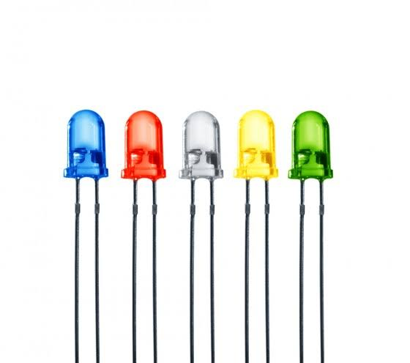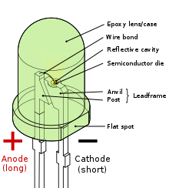

Fig.10.1. Light emitting diodes (LEDs) Fig.10.2. Parts of LED

**LCD DISPLAY**

An LCD is an electronic display module which uses liquid crystal to produce a visible image. The 16*2 LCD display is a very basic module used in circuits. The 16*2 translates a display 16 characters per line in 2 such lines. In this LCD each character is displayed in a 5*7 pixel matrix.

A 16*2 LCD has two registers, namely command and data. The register select is used to switch from one register to the other. RS (Register select)=0 for command register and RS=1 for data register.

Command Register- The command register stores the command instructions given to the LCD. A command is an instruction given to LCD to do a predefined task. The command register processes the commands.

Data Register-The data register stores the data to be displayed on the LCD. The data is the ASCII value of the character to be displayed on the LCD. The data register processes the data sent to the LCD.

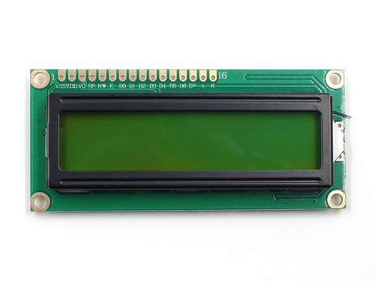

Fig.11.LCD Display

**BUZZER**

A buzzer is an efficient component which adds sound features to our project. A buzzer is a mechanical, electromechanical, magnetic, electromagnetic, electro-acoustic or piezoelectric audio signalling device. The buzzer consists of an outside case with two pins to attach it to power and ground.

When current is applied to the buzzer it causes the ceramic disk to contract or expand. Changing this causes the surrounding disc to vibrate. By changing the frequency of the buzzer, the speed of the vibrations changes, which changes the pitch of the resulting sound.

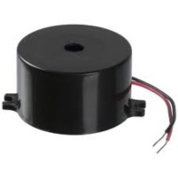

Fig.12.Buzzer

**RESULTS**

Lane Discipline is the most important fact, the commuters are not at all having road knowledge and they drive or ride wherever they wish to. This might be done in a hurry to reach their destinations but it is definitely not encouraged to do so. The civilians have to follow a set of instructions and rules for their safety. Having followed the rules would benefit everybody.

The left lane will be dedicated to the buses. As the barriers to demarcate the bus lane to ensure that the other vehicles do not enter have failed our project has come up with a solution. Installation of the Ultrasonic sensors at the bus lanes would send corresponding signals to the arduino according to the entry of a bus or any other vehicle being a motorbike, car etc. The arduino programs according to the given signal and gives the output accordingly.

Our project would help the proposed idea of the bus lane to work efficiently and help in reducing traffic and also increase the efficient use of the public transport.

**ADVANTAGES**

* Bus lanes reduce stress, travel time for drivers.
* Increased ridership for BMTC
* Reduces traffic congestion
* Efficient use of public transport

**LIMITATIONS**

As one PIR sensor will be placed on top at the height of the bus there will be chances of any other vehicle other than BMTC buses to enter the bus lane and the GREEN LED will still glow.

**CONCLUSION**

Following the bus lane rules would enhance the performance of BMTC buses in terms of their travel time, ridership and revenue. This would increase completion of additional trips which were getting cancelled earlier due to excessive congestion. This would give a significant success for the corridor from the point of view of bus users. The city will have to build on this to ensure that the bus lane project becomes a permanent fixture.

Our project can be upgraded with the enforcement of technology, by considering CCTV’s along the bus lanes to capture license plates of motorists and vehicles other than the BMTC buses. The captured image can be used to generate fine to the respective vehicles using a GSM module.

**APPENDICES**

|  |  |
| --- | --- |
| **ABSTRACT** | PAGE 5 |
| **ACKNOWLEDGEMENT** | PAGE 3 |
| **BIBLIOGRAPHY** | PAGE 25 |
| **BLOCK DIAGRAM** | PAGE 8 |
| **CIRCUIT DIAGRAM** | PAGE9 |
| **CIRCUIT WORKING** | PAGE 10 |
| **CONCLUSION** | PAGE 23 |
| **HARDWARE REQUIREMENTS** | PAGE 14 |
| **INTRODUCTION** | PAGE 6 |
| **RESULTS** | PAGE21 |

**BIBLIOGRAPHY**

* http://www.electronics-manufacturers.com
* www.tinkercad.com
* Timesofindia.indiatimes.com
* www.thenewsminute.com
* Principles of electronics by V.K. Mehta